Practical no. 21
Name :- Danish Altaf Solkar Enrolment no. :-24111590805
Class :- CO3K – B Subject :- DMS
Aim:- Create Implicit and Explicit Cursors.

Program :-
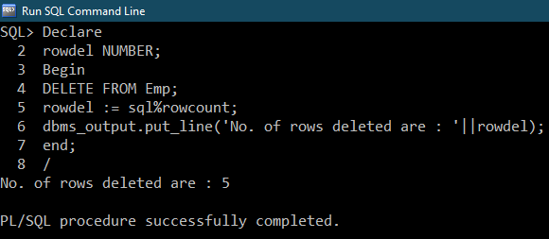
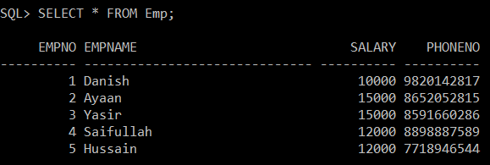

Program :-
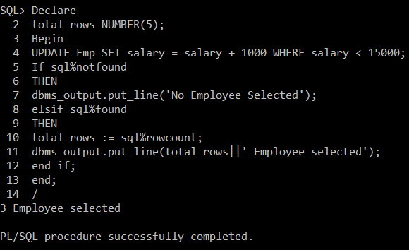
Program :-
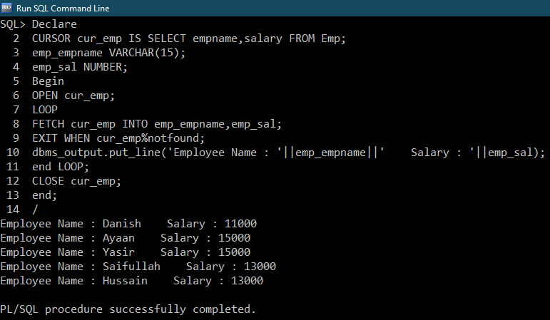

Program :-
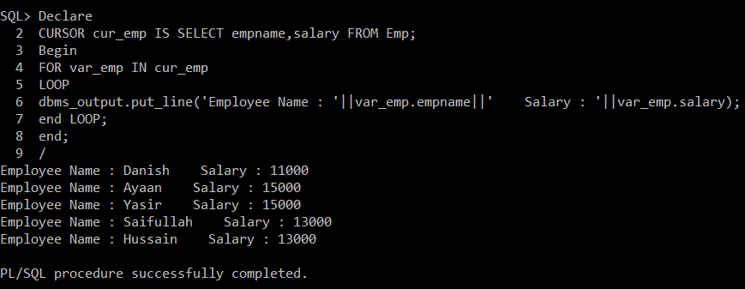

EXERCISE :-
b) Program :-
